

**ISE 533: Integrative Analytics, Spring 2020**

**COVID-19 Analysis**

**By:**

**Zelong Chen**

## 

**Abstract** **3**

**Goal and Scope of Project** **3**

**Overview of Models/Algorithms** **4**

SEIR-D Model 4

SEIR-D Model + Stay-At-Home Order 5

SEIR-D Model + Contact Tracing / Testing 6

All-in-One Model 7

**Data Sources** **7**

Parameter Assumptions 7

Mobility Trend Data 8

**Discussion of Results** **10**

Stay-At-Home Order 10

Contact Tracing / Testing 11

All-in-One 12

**Future Work** **13**

Resource Simulation 13

Reinfection 13

Length of Quarantine 13

## 

## **Abstract**

In this project we look to compare the disease progression of the COVID-19 Coronavirus in the state of California under different operating assumptions. We want to analyze the effectiveness of the implementations put in place by California state officials that are aimed to lower the spread of the Coronavirus and “flatten the curve”. We will be focusing on the analysis of the Stay-At-Home Order and Coronavirus Testing / Contact Tracing. The Stay-At-Home Order was implemented to encourage citizens to remain at home to lower the number of unnecessary social contacts between individuals in order to reduce the spread of the virus. Coronavirus Testing / Contact Tracing was used to detect asymptomatic carriers and any individuals in contact with the carriers, in order to place them into quarantine to prevent further spread of the virus to the general population. This project will look to study both of these implementations separately first to analyze each of their effectiveness. Then combining both implementations to compare the overall effects of these interventions under different operating conditions versus a baseline of the disease progression without any interventions.

## **Goal and Scope of Project**

We aim to model the COVID-19 virus as an infectious disease under the SEIR (Susceptible, Exposed, Infectious, Recovered) Compartmental Model. In addition to these four compartments, we will also add in a Death compartment to simulate and analyze the death tolls due to the Coronavirus. Using this model we will model the disease progression under different operating conditions such as with Stay-At-Home Order and/or Coronavirus Testing / Contact Tracing. We will use the program Anylogic to perform system dynamics modeling that will simulate the spread of the COVID-19 virus as it spreads through the population of California. Details of the models are explained in later sections. We hope to analyze the effectiveness of these implementations put in place by the state officials to lower the spread of the Coronavirus and “flatten the curve”. For this analysis, we will not be studying the possibility of reinfection after recovering from the virus as there is not enough data currently to support this. Thus, this project will simulate the disease progression of the disease from Susceptible to Exposed to Infectious to either Recovered / Death.

## **Overview of Models/Algorithms**

### **SEIR-D Model**

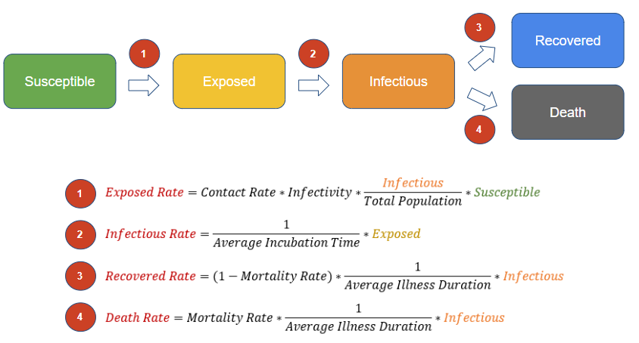

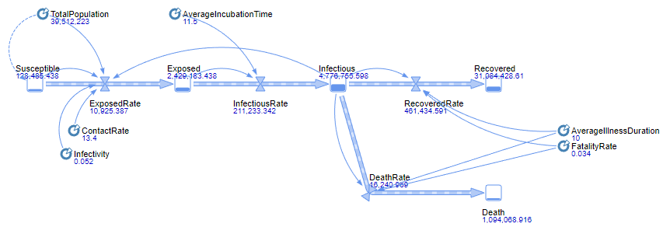

SEIR-D is an infectious disease model that was based on the SEIR (Susceptible Exposed Infectious and Recovered) Model with the addition of a Death Stock. The model contains Stocks and Flows, where Stocks contain a portion of the population during simulation while Flows are defined to be the rate of flow of population from one Stock to another. The model is shown above, where the initial population will start out in the Susceptible Stock and flow toward the Exposed Stock, then toward Infectious Stock, and end up either Recovered or Death Stock at the end. Each of the flow rate will be defined in the figure above and in more details below:

* Exposed Rate
  + Average number of contacts per day * Probability of transmission when exposed * (Number of infectious individuals / Total population of california) * Number of susceptible individuals
* Infectious Rate
  + (1 / Average Incubation time of COVID-19) * Number of exposed individuals
* Death Rate
  + Mortality rate of COVID-19 * (1 / Average illness duration) * Number of infectious individuals
* Recovered Rate
  + (1 - Mortality rate of COVID-19) * 1 / Average illness duration * Number of infectious individuals
* Note: Parameters above are defined and explained in the Data Sources: Parameter Assumptions Section below

SEIR-D will be our baseline model that will simulate the disease growth without any intervention implemented from the California State Officials.

### **SEIR-D Model + Stay-At-Home Order**

### 



* Parameters for this model: Mobility Trend = 70%, 40%, 25%, 10%

This model is an extension of the SEIR-D Model with the addition of the parameter of Mobility Trend. Mobility Trend is the representation of the effects from the Stay-At-Home Order issued by the state of California that encourages citizens to stay home to reduce the spread of the coronavirus. Mobility Trend parameter is defined by the decrease in percentage of transmission rate due to citizens staying home and lowering individuals' contact rate daily. We will run the model under the operating condition of 70%, 40%, 25%, and 10% as explained in the Data Sources Section under Mobility Trend Data.

### **SEIR-D Model + Contact Tracing / Testing**

### 

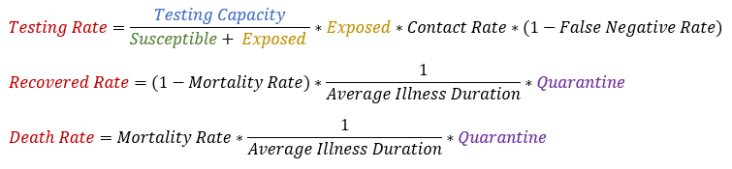

* Parameters for this model: Testing Capacity = 16,000, 25,000, 70,000

This model is an extension of the SEIR-D Model with the addition of a Testing and Contact Tracing option that affects the Exposed Stock. In California, the government set up limited drive-in testing sites for citizens to test for the Coronavirus. This implementation is used to find infected individuals within the population and through contact tracing to find others who are potentially infected in order to quarantine them from the remaining population. For example, an individual in the Exposed Stock can be tested for COVID-19, and if the test is positive, then the individual and all that came into contact with them will go into Quarantine. In this model we assume that we can trace the disease spread through each infected individual by the average rate of social contact per day (13.4/day). When in Quarantine, infected individuals will not be able to infect the Susceptible population and they will just either enter the Recover or Death stock based on the rates stated above. The rate of flow from Exposed Stock to the Quarantine Stock is also stated in the equation above, where it is mainly dependent on the parameters of Testing Capacity per day and the False Negative Rate of the tests. Testing Capacity and False Negative Rate is discussed below in the Data Sources: Parameter Assumptions section.

### **All-in-One Model**

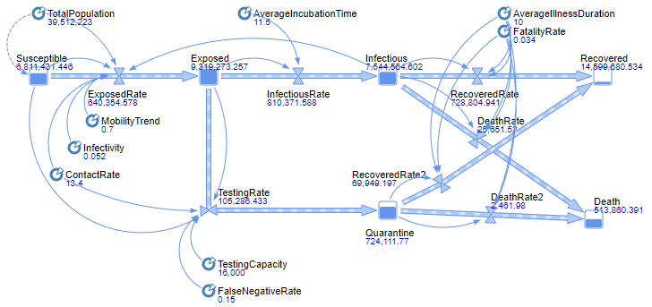

* Parameters for this model: (Mobility Trend, Testing Capacity) = (0.4, 16,000), (0.4, 70,000), (0.7, 16,000), (0.7, 70,000)

This model is a combination of the two previous models or the baseline SEIR-D Model with the addition of both Stay-At-Home Order and Contact Tracing / Testing. Refer to the previous two sections on details of these two implementations. In this model we will run the simulation on different permutations of the parameters of Mobility Trend and Testing Capacity listed above. The simulation will give us a sense of our progress compared to the baseline due to these interventions put in place by California state officials (i.e. Stay-At-Home Order and Contact Tracing / Testing). Note, the permutation of (Mobility Trend = 0.4, Testing Capacity = 16,000) represents the current situation in the state of California as of 4/24/20.

## **Data Sources**

### **Parameter Assumptions**

* Contact Rate: 13.4 contacts per day
  + According to a study done on Social Contacts and Mixing Patterns to the Spread of Infectious Diseases
  + <https://journals.plos.org/plosmedicine/article?id=10.1371/journal.pmed.0050074#s1>
* Infectivity: 5.249%
  + Based on initial infectious data from Hubei Province
  + <http://jtd.amegroups.com/article/view/36385/html>
* Average Incubation Period: 11.5 days
  + According to the CDC, 97.5% of patients with COVID-19 develop symptoms within 11.5 days
  + <https://www.cdc.gov/coronavirus/2019-ncov/hcp/clinical-guidance-management-patients.html>
* Average Illness Duration: 10 days
  + According to the CDC, patients may discontinue isolation if at least 10 days have passed since symptoms first appeared.
  + <https://www.cdc.gov/coronavirus/2019-ncov/hcp/disposition-in-home-patients.html>
* Mortality Rate: 3.4%
  + World Health Organization media briefing on COVID-19 on March 3 2020
  + <https://www.who.int/dg/speeches/detail/who-director-general-s-opening-remarks-at-the-media-briefing-on-covid-19---3-march-2020>
* Initial Infectious Population: 699
  + The number of confirmed cases in California the day before Stay-At-Home order issued by the California governor
  + <https://www.cnbc.com/2020/03/19/california-governor-issues-statewide-order-to-stay-at-home-effective-thursday-evening.html>
* California Population: 39,512,223
  + According to the US Census Bureau on 7/1/2019
  + <https://www.census.gov/quickfacts/CA>
* Testing Capacity: 16,000, 25,000, 70,000
  + As of 4/24/20 California has a capacity of conducting 16,000 COVID-19 tests per day and they look to increase to 25,000 by May. In addition, they aim to reach at between 60,000-80,000 in order to consider reopening the state.
  + <https://www.nytimes.com/2020/04/24/us/coronavirus-covid-get-antibody-testing.html>
* False Negative Test Rate: 15%
  + Due to the massive demand of COVID-19 testing kits, rushed production of these kits have about an 15% rate of failure to detect the virus
  + <https://www.cnn.com/2020/04/21/health/abbott-laboratories-coronavirus-rapid-test/index.html>

### **Mobility Trend Data**

Based on Apple Maps Mobility Trends Report and Google COVID-19 Community Mobility Report:

**Apple:**

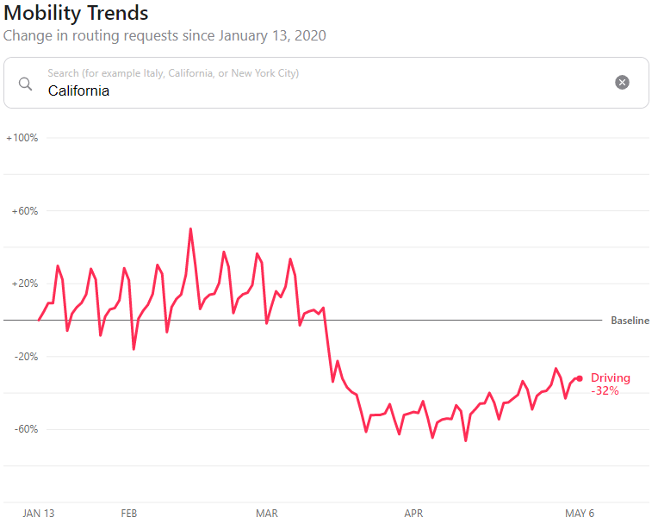

**Google:**

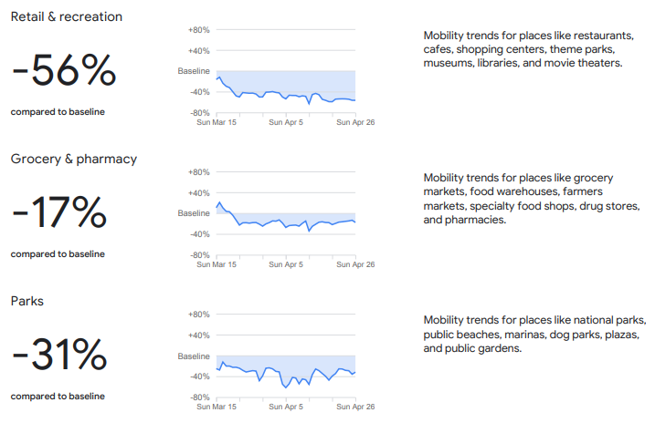

Source: <https://www.apple.com/covid19/mobility>, <https://www.gstatic.com/covid19/mobility/2020-04-26_US_California_Mobility_Report_en.pdf>

* From the mobility data above we can see that the best efforts from Stay-At-Home Order reached up to a 60% decrease in mobility, while around 30% decrease on average. Thus, our parameters for Mobility Trend for the SEIR-D Model + Stay-At-Home Order will be 70%, 40% of the normal rate of transmission. In addition we will also run simulations on 25% and 10% of the normal rate of transmission to simulate the strict lockdown that occured in China.

## **Discussion of Results**

### **Stay-At-Home Order**

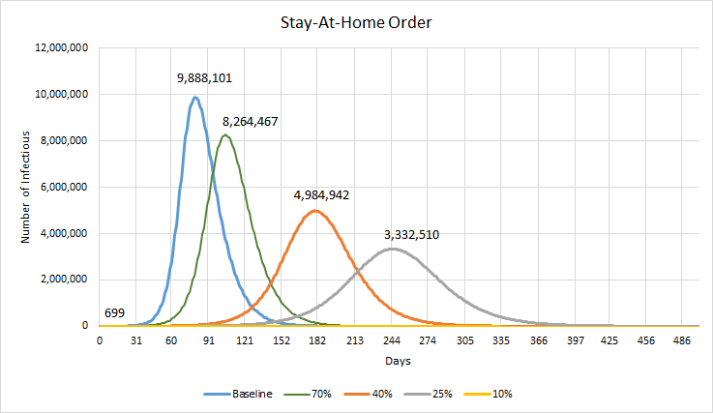

From the results above, the blue curve represents the baseline of the disease progression of COVID-19 without any interventions. 70% represents the average / current mobility trend of California under Stay-At-Home Order. We can see that the effects of the Stay-At-Home order at 70% mobility is able to reduce the infectious population by -16.42%. At 40% mobility, which represents California’s best efforts and lowest mobility trend during the Stay-At-Home order was able to reduce the infectious population by -49.59%. It is interesting to note that with very strict lockdown intervention (i.e. 10% mobility), similar to the ones that occured in China, the infectious population will not grow exponentially at all. Thus, showing that Stay-At-Home order is an essential intervention that effectively decreases the spread of the Coronavirus and helps tremendously in “flattening the curve.” In addition to decreasing the spread of Coronavirus, lower mobility trends also delays the peak of infection. Which will allow the state of California to have additional time to prepare the necessary resources such as hospital beds, invasive ventilators, and personal protection equipment to combat the large influx of patients during the peak of infection.

### **Contact Tracing / Testing**

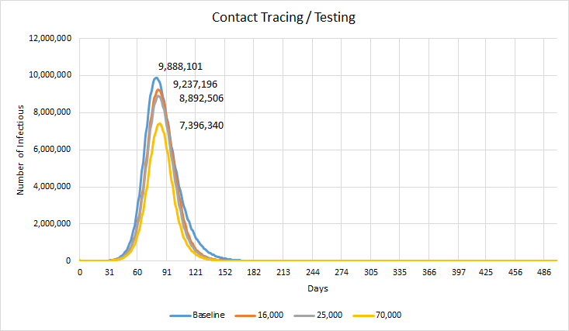

Results from the simulation of SEIR-D + Contact Tracing/Testing is shown above. When compared to the baseline, we can see that the current capacity of testing available in California (16,000 and 25,000 in May) did have an effect on lowering the peak of the curve. However the respective percent change of peak infectious patients are -6.58% and -10.07%. Although this is a good indication of the effects brought on by Contact Tracing/Testing to lower the spread of the virus, we can see that California is still behind in providing the necessary testing kits. The result suggests that we need to reach the capacity of 70,000 to have an large impact on lowering the spread of the Coronavirus, with a -25.2% decrease in the number of infections. If combined with the Stay-At-Home Order, it can lead to reopening the state sooner.

### **All-in-One**

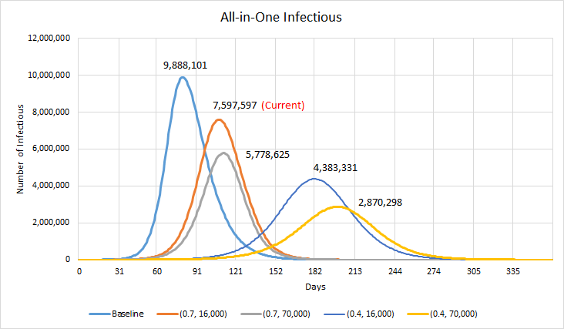

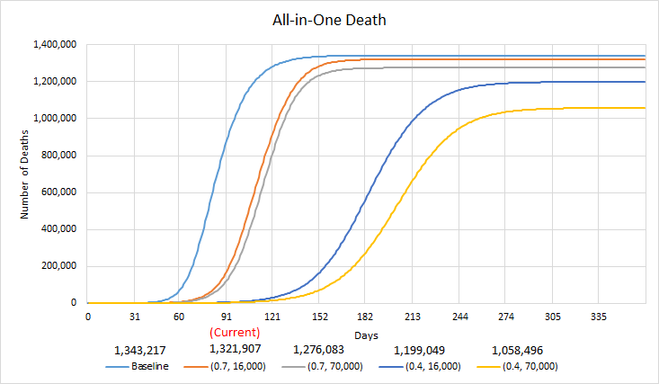

Results of the number of infectious and death from the All-in-One model is shown above. All-in-One includes both interventions of Stay-At-Home Order and Contact Tracing / Testing with different permutation of parameters. The orange curve above represents the current situation in California with Stay-At-Home Order reducing mobility trends to about 70% and COVID-19 capacity of 16,000 tests per day. When compared to the blue baseline model with no interventions put in place, the current situation decreases the peak infection by -23.16% and total death by -1.59%. These results show that we are making good progress in lowering the spread of Coronavirus through these interventions. But as mentioned before the most effective way to lower the spread is to enforce a strict Stay-At-Home Order to lower the mobility trend of citizens, which in terms will lower the spread of the virus by a significant amount. For example, with a mobility trend of 40% and test capacity of 16,000, can decrease the peak infection by -55.67% and total death by -10.73%.

As of 05/12/2020, California has reported 67,939 confirmed COVID-19 cases and 2,770 deaths according to the CDC website. It has been 54 days since the Stay-At-Home order was issued. The simulation results are higher than real data. Possible reasons for the discrepancies can be the inaccuracy of data that we used for simulation. We used the infectious rate of Hubei Province, which is higher than that of the real situation in California.

## **Future Work**

### **Resource Simulation**

* Add models to simulate the usage of hospital beds, health-care workers’ hours, invasive ventilators, and personal protection equipment under different operating conditions to give us an insight on the demand on these essential resources.

### **Reinfection**

* Additional parameters that allow recovered patients to return to the susceptible population again. This will allow us to see the effects of a worst case scenario where the virus is allowed to reinfect recovered patients.

### **Length of Quarantine**

* Additional parameters and constraints that simulate certain lengths of Stay-At-Home Order. (I.e. 1 month with Stay-At-Home Order with mobility down to 40%, then opening the state and returning to normal mobility after 1 month of simulation)